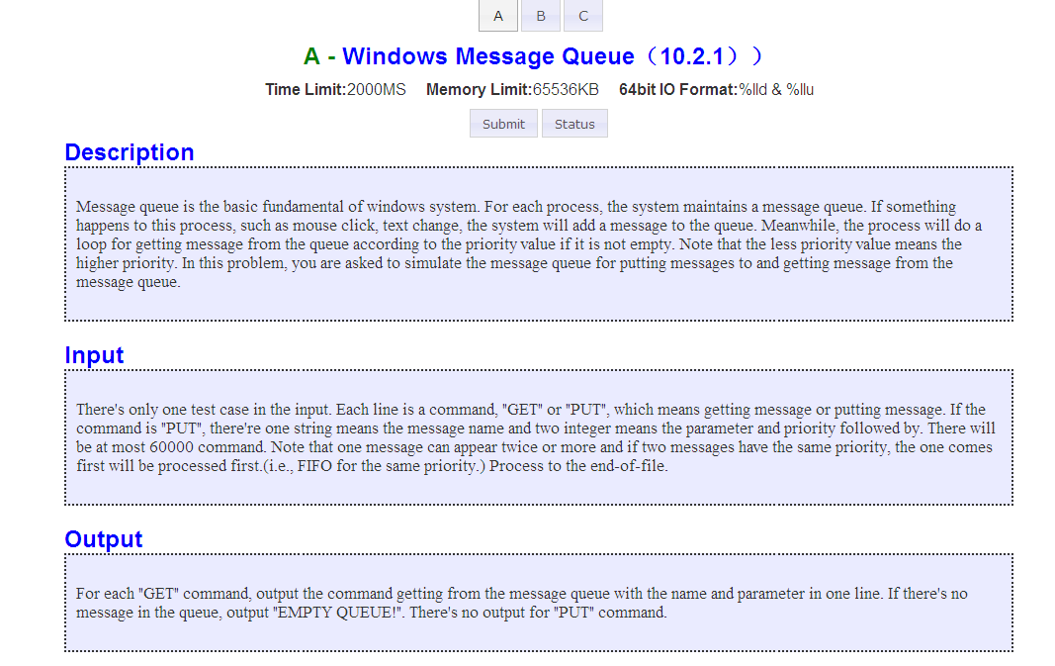
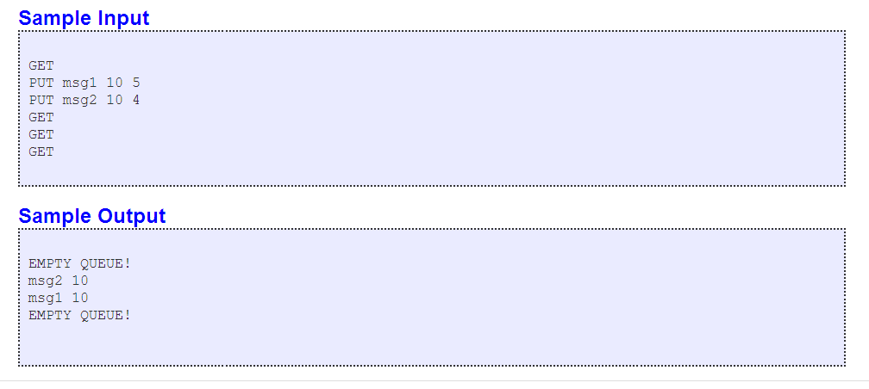
GET
PUT msg1 10 5
PUT msg2 10 4
PUT msg3 10 3
PUT msg4 10 4
GET
GET
GET
GET

居然又是一次AC了 看来我还没想象中那么笨
#include <iostream>
using namespace std;
char str[4];int heap[60001];
struct info
{
char name[1001];
int para;
int pri,t;
}p[60001];
int compare(int a,int b)
{
if(p[a].pri<p[b].pri)
return -1;
if(p[a].pri>p[b].pri)
return 1;
if(p[a].t<p[b].t)
return -1;
if(p[a].t>p[b].t)
return 1;
return 0;
}
int main()
{
int top=0;int cnt=0;
while(cin>>str)
{
if(str[0]=='G')
{
if(top)
{
cout<<p[heap[1]].name<<" "<<p[heap[1]].para<<endl;
int k=1;
heap[k]=heap[top--];
while(k*2<=top)
{
int t=k*2;
if(t<top&&compare(heap[t+1],heap[t])<0)
t++;
if(compare(heap[t],heap[k])<0)
{
swap(heap[t],heap[k]);
k=t;
}
else
break;
}
}
else
cout<<"EMPTY QUEUE!"<<endl;
}
if(str[0]=='P')
{
int i=++cnt;
p[i].t=i;
cin>>p[i].name>>p[i].para>>p[i].pri;
int k=++top;
heap[k]=i;
while(k>1)
{
int t=k/2;
if(compare(heap[t],heap[k])>0)
{
swap(heap[t],heap[k]);
k=t;
}
else
break;
}
}
}
return 0;
}
比较下面这一种 这个交上去是wrong answer 为什么
#include <iostream>
using namespace std;
struct info
{
char name[100];
int para;
int pri,t;
}p[60001];
int compare(int a,int b)
{
if(p[a].pri<p[b].pri)
return 1;
if(p[a].pri>p[b].pri)
return -1;
if(p[a].t<p[b].t)
return -1;
if(p[a].t>p[b].t)
return 1;
return 0;
}
char str[4];
int main()
{
int cnt=0,top=0;
while(cin>>str)
{
if(str[0]=='G')
{
if(top>0)
{
cout<<p[1].name<<" "<<p[1].para<<endl;
int k=1;
p[k]=p[top--];
while(k*2<=top)
{
int t=k*2;
if(compare(t+1,t)<0)
t++;
if(compare(t,k)<0)
{
swap(p[k],p[t]);
k=t;
}
else
break;
}

}
else
cout<<"EMPTY QUEUE!"<<endl;
}
if(str[0]=='P')
{
int i=++cnt;
p[i].t=i;
cin>>p[i].name>>p[i].para>>p[i].pri;
int k=++top;
while(k>1)
{
int t=k/2;
if(compare(k,t)<0)
{
swap(p[k],p[t]);
k=t;
}
else
break;
}
}
}
return 0;
}

